Question 1. Marks

- Let 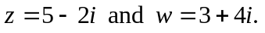

(i) Find 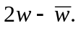 2

(ii) Find 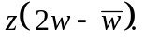 2

- Given 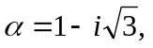

(i) Find the exact value of 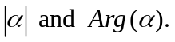 2
(ii) Hence or otherwise, find the exact value of 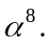 3
[express in the form 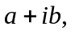 where a and b are real numbers]

- Find the new complex number when 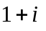 is rotated 60⁰ anticlockwise 2
about the origin O, in the Argand plane.

(d) Find x and y, when 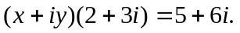 2

- Given 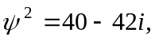 2

Find 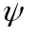 in the form where a and b are real.

Question 2. [START A NEW PAGE]

(a) Shade the region of the Argand plane consisting of those variable
points z for which:

(i) 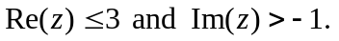 1

(ii) 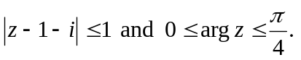 2

(b) Find the equation of the locus of z, if 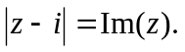 3
Sketch the locus on an Argand plane.

(c) Find the equation of the locus of z when 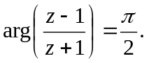 2

Marks
Q 2. continued

- Given that 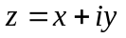is a variable point on the Argand plane such that
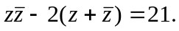

(i) Find the locus of z. 2

- Hence determine the maximum value of: 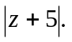 2

(e) Given 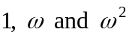 are the cube roots of unity and each are 3
represented by the points A₁, A₂ and A₃ respectively on an Argand plane.

Find the value of 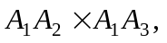 where ‘A₁A₂’ represents the length 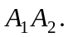

Question 3. [START A NEW PAGE]

- Point A represents the complex number α and the point P represents 2
the complex number z.
Point P is rotated about the point A through a right angle in an
anticlockwise direction to take up the new position, B, representing the
complex number β.

Find β (in terms of α and z).

- Given 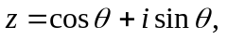

(i) Use De Moivre’s theorem, to show that 2

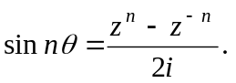

(ii) Hence deduce that: 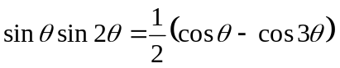 3

(c) Given the complex number z, such that 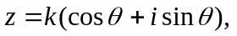 3
where k is a real number and 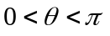.
Show that: 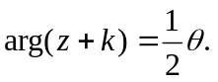

Marks
Q 3. continued

- Given 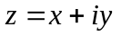 is a variable point and 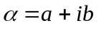 is a fixed point on
the Argand plane,

(i) Show that 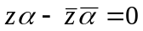 represents a straight line through 2
the origin O.

(ii) Suppose that z₁ and z₂ are the solutions to the simultaneous 3
equations: and 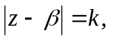
where 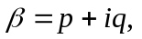 and where p, q and k are positive real numbers,

show that 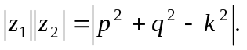

Question 4. [START A NEW PAGE]

- Let α, β and γ be the zeros of the polynomial function:
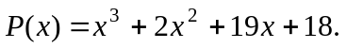

- Find 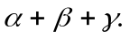 1

- Find 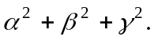 2

- Hence, or otherwise determine how many of the zeros are real. 2
Give reasons.

(b) Consider the polynomial equation: 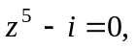

- Show that 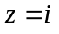 is a solution to the equation, and 2
hence show that 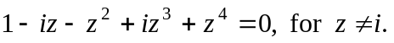

(ii) Hence or otherwise, find all the roots of 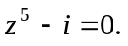 2
[you may leave the roots in 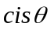 form]

(iii) Show that 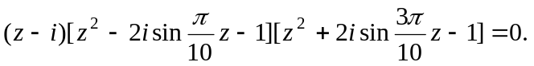 4

(iv) Hence show that: 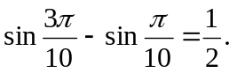 2

THE END
☺ 😐 ☹

